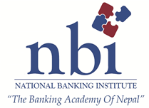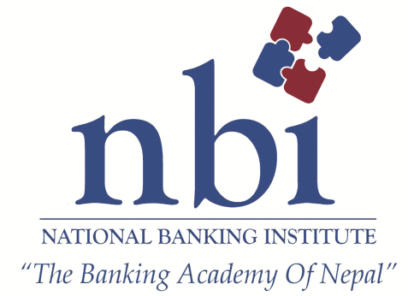 ­

Proposal of

AML/CFT - KYC

For Employees of

Development Banks

Background

The banking industry in Nepal has seen exponential growth. The competitive market has stretched the limits of customer numbers. To tackle these issues, excellent customer service and innovative marketing of one’s banking products becomes essential. With this in mind National Banking Institute brings to you AML/CFT. This program aims to deliver the best course content with consultation with the Industry Experts & Regulatory Intellectuals.

We are pleased to deliver a one day program on AML/CFT to provide knowledge on Money laundering mechanisms and cycles, recent laws passed in June and money laundering based on international and local context.

**Program Takeaways**

**Theoretical, Legal and Practical for:**

* Understanding how a BFI can take business and AML/CFT together
* Understanding how a BFI can best expand business together with AML/CFT compliance
* Understanding how AML/CFT help expanding business
* Understanding how minimum resources and staffs can work on AML/CFT
* Understanding how a BFI can best implement the newly amended but rigorous laws with limited resources
* Understanding Linkage between Banking and AML/CFT measures and their inseparability
* Understanding instruments that help assessing risk and focusing only on the high risk areas
* Understanding the easy modality and benefits of applying AML/CFT (including KYC/CDD) with the institutions
* Understanding the way of dealing with customers in relation to AML/CFT
* Understanding the matters of training to junior staffs to face with the customers
* Understand the measures applicable to face problems regarding AML/CFT in the course of day to day business
* Understanding the matters and mechanisms of reporting to high level officials
* Understanding the supervisory modality and measures to compliance
* Understanding sanctions and their vicious impacts on individual, institution and the national for non-compliance
* Understanding how a BFI can save itself form Regulatory Sanction of 5 Koror and Criminal charge in AML/CFT
* Understanding how AML/CFT policies and procedures are developed for the institution
* Understand the concept, values, benefits of AML/CFT measures together with Nepalese context and their benefits to individual institution

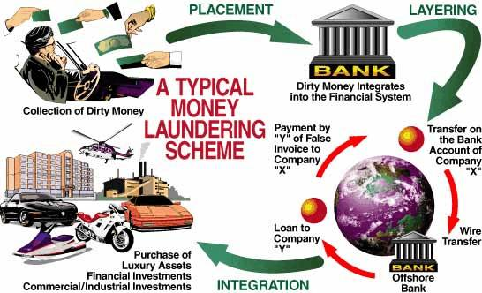

The program aims to equip participants with knowledge on AML/CFT. Upon the completion of the course the participants will gain knowledge and skills that are very essential to be efficient in their field of work. This program will help participants get working procedures.

|  |  |
| --- | --- |
| **Session 1** | * **AML/CFT: General Overview and Nepalese Regime** |
| **Session 2** | * **Preventative Measures and Role of Managers** |
| **Session 3** | * **Risk Based Approach and Policy** * *Customer* * *Product* * *Services* * *Geography* * *Delivery channel* * *Exercise* * **Low cost and effectiveness** * **Minimization of Adverse Impact on BFI** |
| **Session 4** | * **Reading between lines and Reporting** * Monitoring * STR Detection * KYC * Operation and Activities * Outside Information * Matching and mining data * Exercises * Compliance Mechanisms * Supervisory Expectations * Sanctions |

Course Content

s

Program Details

This One day program would be led by leading local experts from the Banking/Regulatory Sector with close inputs from NBI team.

**Date:** 9th September, 2017

**Time:** 9:00AM to 4:00PM

**Venue:** Siddhartha Cottage, Butwal.

**Date:** 16th September, 2017

**Time:** 9:00AM to 4:00PM

**Venue:** NBI Hall, Kathmandu



This is a rare opportunity to learn selling techniques

Trainer

**Mr. Ram Sharan Pokharel**

**Assistant Director**

Nepal Rastra Bank.

"We are **for the industry** and **by the industry**"

National Banking Institute has developed this program in close consultation with leading local experts. We researched the industry need and also thoroughly reviewed program offered by other institutes. The learning outcome has enabled NBI to address and customize the program to the industry need more specifically.

Trainers Detail

Mr. Sumed Bhattarai

Head Corporate Banking

Laxmi Bank Limited

Mr. Nirmal Dahal

Head Credit

Laxmi Bank Limited.

We, do hereby, accept this proposal and would like National Banking Training Institute to organize the program on “Credit Course". Thank You.

Place logo

or logotype here,

otherwise

delete this.

Delete text and place photo here.

Delete text and place photo here.

company

name

|  |  |  |  |  |  |  |
| --- | --- | --- | --- | --- | --- | --- |
| **S** | **M** | **T** | **W** | **T** | **F** | **S** |
| 1 | 2 | 3 | 4 | 5 | 6 | 7 |
| 8 | 9 | 10 | 11 | 12 | 13 | 14 |
| 15 | 16 | 17 | 18 | 19 | 20 | 21 |
| 22 | 23 | 24 | 25 | 26 | 27 | 28 |
| 29 | 30 |  |  |  |  |  |
|  |  |  |  |  |  |  |

**2008**

**june**

 

|  |
| --- |
| * Trainer’s fee. * Training Materials. * Certification. * Stationery (Note pad/Ball point pen. * Tea/ Coffee/ Cookies & Lunch. |

***Note:***

• ***This Program Proposal is valid up to 27TH September 2017.***

• ***Cancellation of programs participants must be done 72 hours prior to start of the program otherwise full charge shall be levied to the client.***

Training Cost Includes

We, do hereby, accept this proposal and would like National Banking Institute to organize the program on “AML/CFT - KYC".

**__________________ ____________________**

**For DBAN For NBI**

National banking institute ltd.

Central Plaza, 6th Floor, Narayanchour, Naxal, Kathmandu, Nepal.

T : 977-1-4415903/905, 4436001 • F : 977-1-4441351

info@nbti.com.np • www.nbi.com.np

Place logo

or logotype here,

otherwise

delete this.

Place logo

or logotype here,

otherwise

delete this.

Delete text and place photo here.

Delete text and place photo here.

company

name

|  |  |  |  |  |  |  |
| --- | --- | --- | --- | --- | --- | --- |
| **S** | **M** | **T** | **W** | **T** | **F** | **S** |
|  |  | 1 | 2 | 3 | 4 | 5 |
| 6 | 7 | 8 | 9 | 10 | 11 | 12 |
| 13 | 14 | 15 | 16 | 17 | 18 | 19 |
| 20 | 21 | 22 | 23 | 24 | 25 | 26 |
| 27 | 28 | 29 | 30 | 31 |  |  |
|  |  |  |  |  |  |  |

**2008**

**january**